Most web apps need some configuration information can be access by application during the runtime.

Configuration Information-

1. Database Connection Strings
2. API keys – which are not user-specific confidential values

But sensitive pieces of information that need to be protected.

It is not a good practice to have such information included in our source code and later, deploy to our servers or publish it to Github, because this way we might give unauthorized users access to really sensitive data in our apps.

A piece of sensitive data is app secret.

And app secrets need to be stored in a separate location from the project tree.

In visual studio , we can use the **Secret Manager tool. To manage our App Secret.**

**Setting App Secret for .Net Core App**

We can set App Secret **Manually or using package manager console**

**Package manager console –**

**Example –** Configure our application Facebook Authentication and to Configure We need Fb ID and Facsebook App Secret.

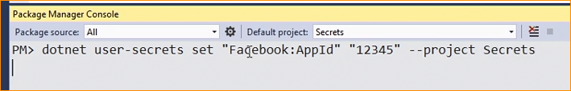



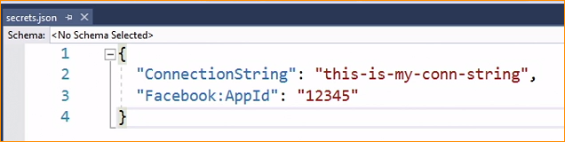

Add Another one



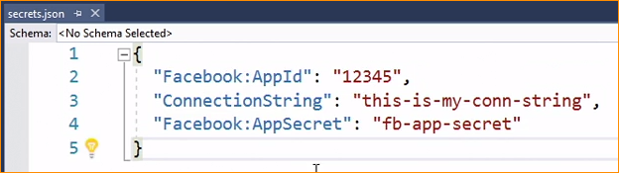

Like this we can set multiple secret as well.

* Get App settings.json data to user secrets

Appsetting.json file-



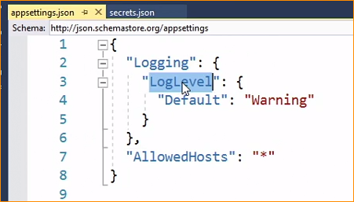

Now user secret file –

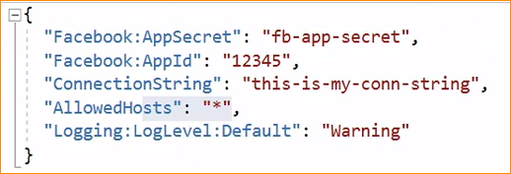

Now How to access the app secret files-

To Accessing Secrets –

* We can use the key value
* We can create a POCO class only with the secret properties

Go to the secret file Using package manager console-

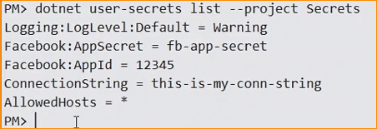

Now can see we have five Secrets

How to access them in our controllers

One way 1. Using the default configuration file – in here we need to place us the parameter of a key.

Go to controller file

**And inject the IConfiguration file –**

My Secret file -

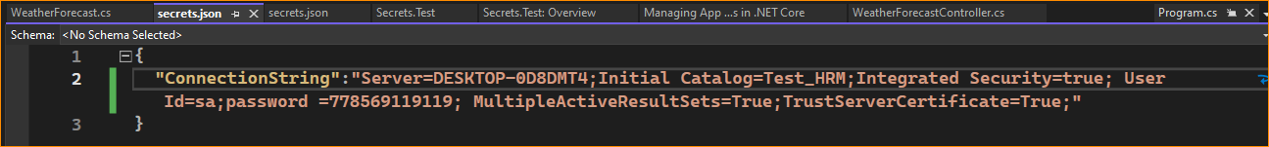.

Get access using IConfiguration-

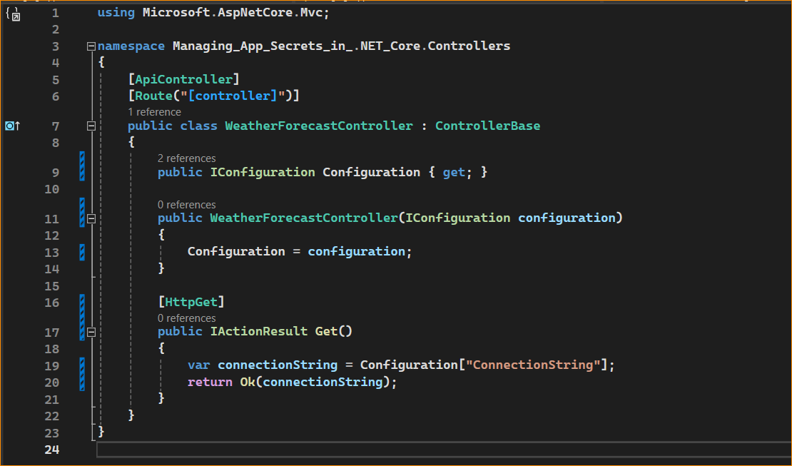

Result –

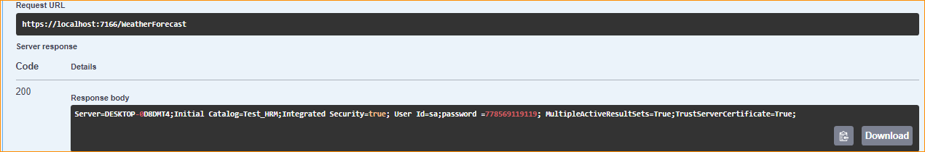

Get using POCO Class –

Now my use secret -

Create model –

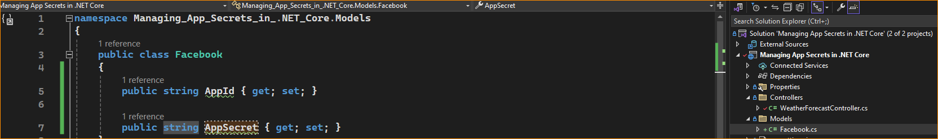

Access the using model –

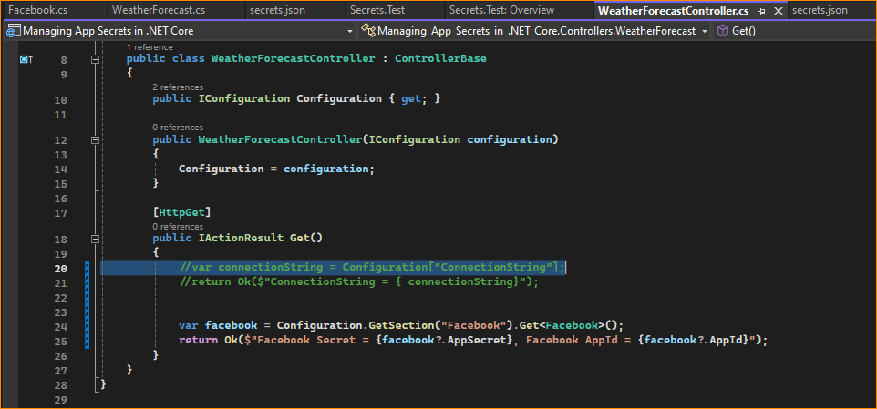

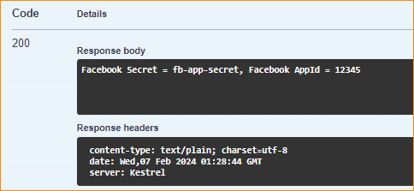

**Replacing and Removing Secrets-**

Using the app some time you have to update the user secret or some time you have to remove, that not using any more-

List -

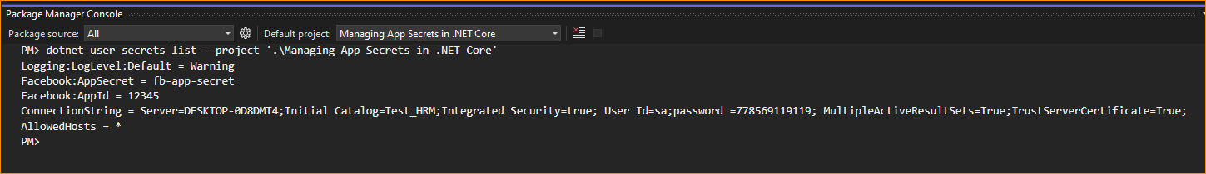

If we want to remove connection string-

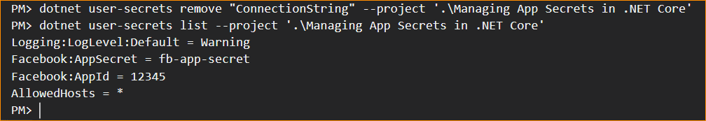

Update –

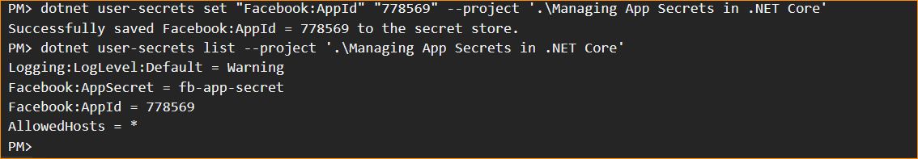

Add new Value –

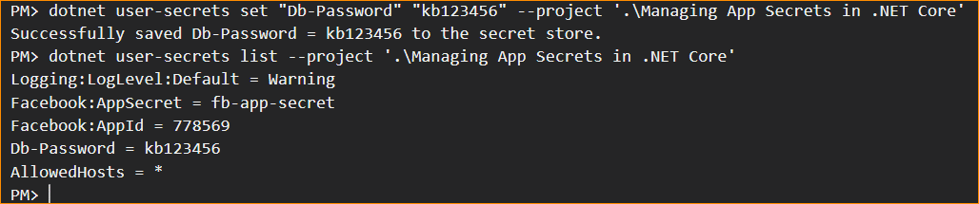

Enter connection string – without password and make a password differently

And set separately

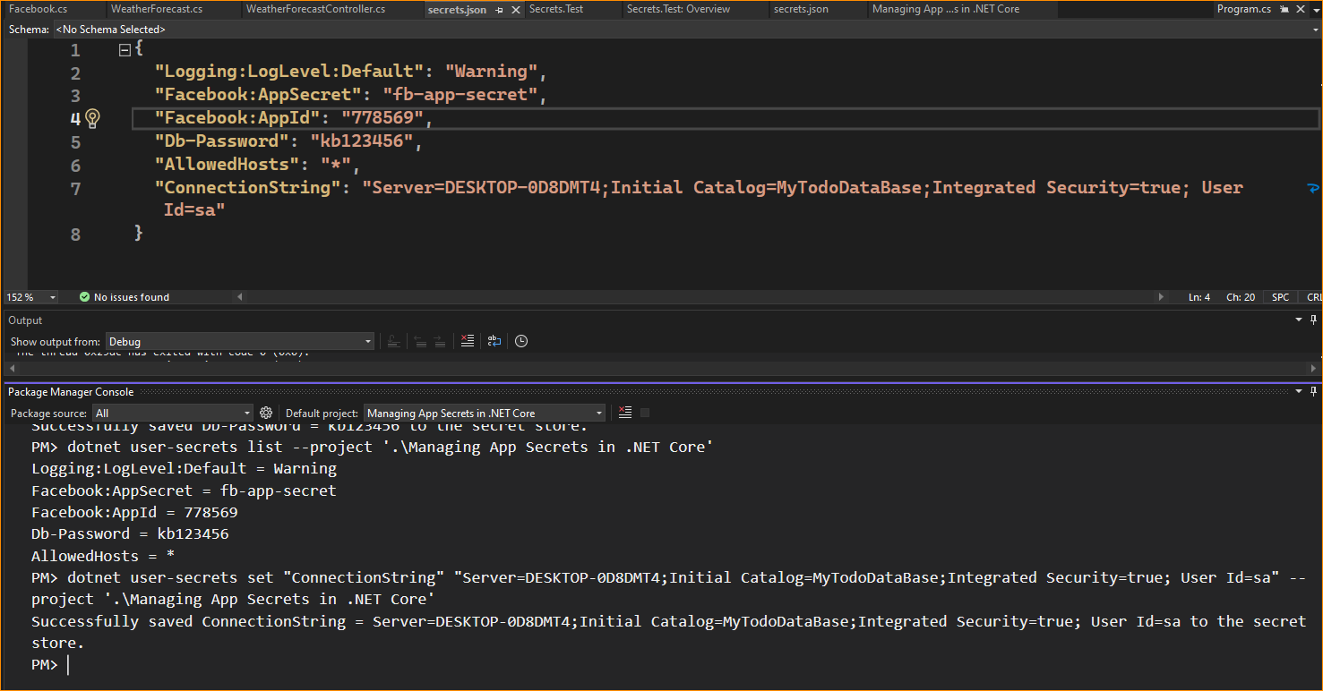

Now here in the Connection string no Password

Not set the connection string and password.

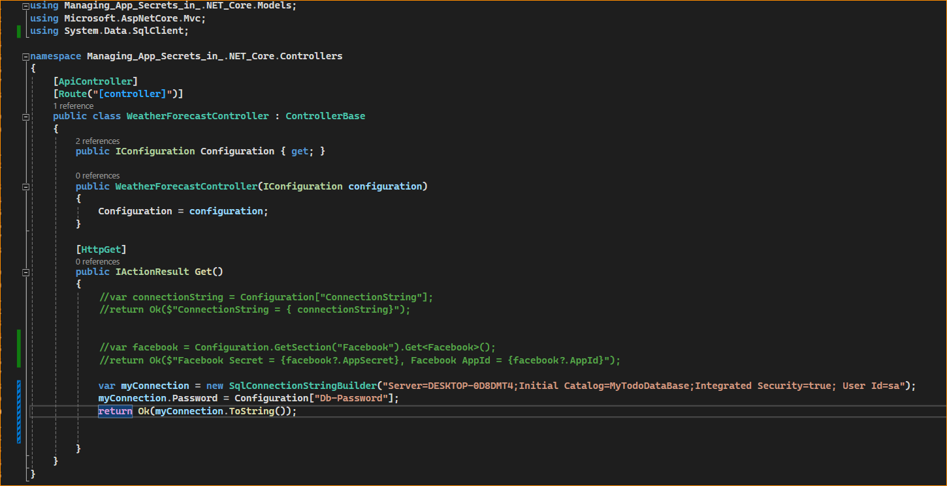



Check –

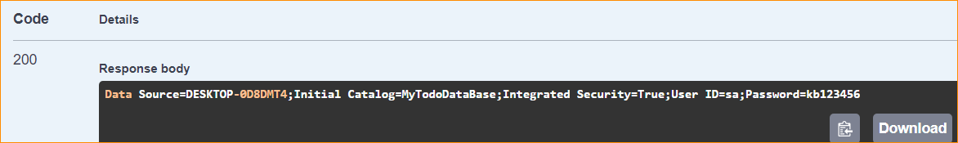

Now you can see the auto set the password

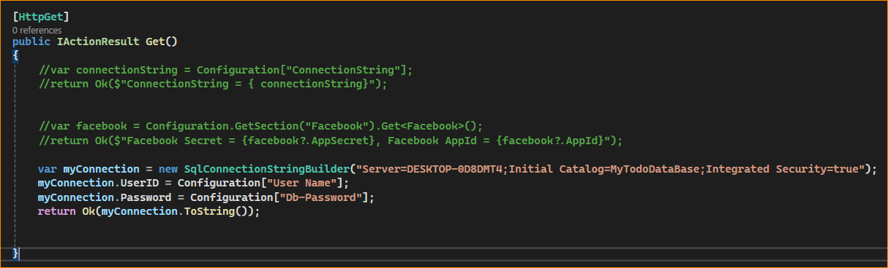

In here like this- you can set connection string like this

